15. X Carriage Assembly

Vitamins
8 Zip-tie 100mm min length

Printed parts
1 P3Steel_i3_Rework_X-carriage_1a.stl
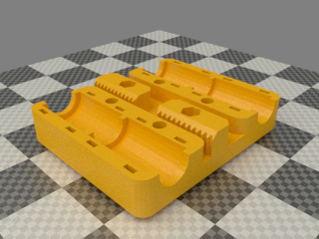

Assembly

- Push the carriage on the bushings and secure each one with two zip ties.

